101 fun things to do with preschoolers
Keren Perles
Jan. 15, 2020
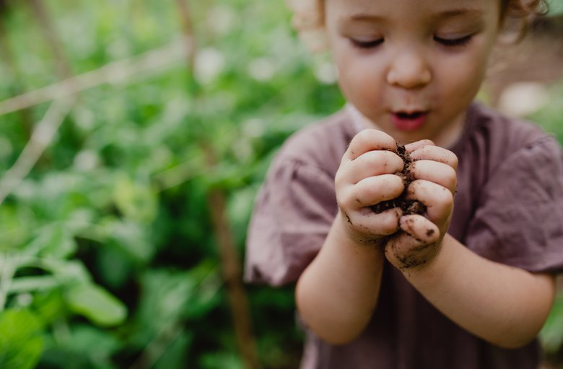
Here are 101 things to do with preschoolers, including suggestions provided by Dr. Amanda Gummer, an expert on child play:
- Create a bubble painting.
- Create a marble painting.
- Craft a story together.
- Dig in the dirt.
- Bag leaves together.
- Make an obstacle course.
- Bake together.
- Fold towels.
- Play a rhyming game.
- Build a house of cups.
- Go on a walking tour of your city.
- Play dress-up.
- Make a path of pillows to use as stepping stones.
- Write a book.
- Make a snow dollhouse.
- Volunteer.
- Play I Spy with colors.
- Draw pictures in chalk on the sidewalk.
- Make a popsicle-stick craft.
- Play Simon Says with the whole family.
- Make a large box into a playhouse.
- Play Red Light, Green Light.
- Complete a connect-the-dots picture.
- Go fishing using kitchen magnets.
- Lie on your back outside and find pictures in the clouds.
- Make a leaf collage.
- Make a musical parade.
- Craft with clay.
- Make a birdfeeder.
- Build a snow city.
- Play Finger Twister.
- Jump rope or hula-hoop.
- Make a cereal necklace.
- Play Freeze Tag.
- Do a puzzle.
- Play Hide and Seek.
- Play tag.
- Build a city out of toys.
- Make a tea party.
- Play Go Fish.
- Build a fort with a blanket, some pillows and durable furniture.
- Put on a sock-puppet play.
- Dress up your child as a superhero — you play the bad guy.
- Explore outdoors with a magnifying glass.
- Play catch with a balloon.
- Kick a ball into a goal.
- Go sledding.
- Sort leaves by color and size.
- Make an acorn collection.
- Spread hummus on a rice cake and make a face out of vegetable pieces.
- Practice tumbling.
- Challenge your child to identify items by smell.
- Pretend to go on an African safari.
- Play hopscotch.
- Make "stained glass" with tissue paper and clear contact paper.
- Build a dollhouse out of shoeboxes.
- Bowl using empty soda bottles as pins.
- Play charades together.
- Create a collage from old magazines.
- Pop balloons with your body.
- Sort coins.
- Trace yourselves on butcher paper and decorate.
- Go on an outdoor scavenger hunt.
- Make a car wash for riding toys.
- Plant a seed and watch it grow.
- Sort things by colors.
- Jump rope.
- Create a spider web with glue-coated spaghetti.
- Race pompoms by blowing them with a straw.
- Make paper-bag masks and decorate them.
- Play Follow the Leader.
- Play the card game War.
- Pretend to be firefighters.
- Fly a kite.
- Make a volcano out of baking soda, vinegar and red food coloring.
- Make sushi together.
- Decorate umbrellas with foam shapes.
- Build a structure from marshmallows and toothpicks.
- Use different objects (like a wire coat hanger) to make soap bubbles.
- Play "What Time Is It, Mr. Fox?"
- Let your child "read" you a storybook by looking at the pictures.
- Play doctor.
- Make art with pinecones.
- Polish each other's nails.
- Make hand shadows.
- Exercise with a yoga video together.
- Play a simple version of Pictionary.
- Make a paper-bag puppet.
- Keep a balloon in the air as long as possible.
- Play Hot and Cold with a hidden object.
- Cut snowflakes from folded paper and decorate them.
- Play a matching game with photos of family members.
- Have a picnic lunch.
- Call out words and challenge your child to think of rhymes for each one.
- Let your child scrub carrots or potatoes for dinner.
- Use cooking tools to play with water.
- Copy each other's rhythms on a toy drum.
- Tilt a cookie sheet on a stack of books to make a slide for toy cars.
- Crawl under a sheet and pretend you're lost in a cave.
- Race to find the biggest rock or leaf.
- Make fruit kebabs.
The key to having fun with your preschooler is to join in and let them take charge, according to Carroll. So flop down on the carpet and try one of these things to do with preschoolers. You'll have a blast — and your child will too!

