HELP US FIND IZZY
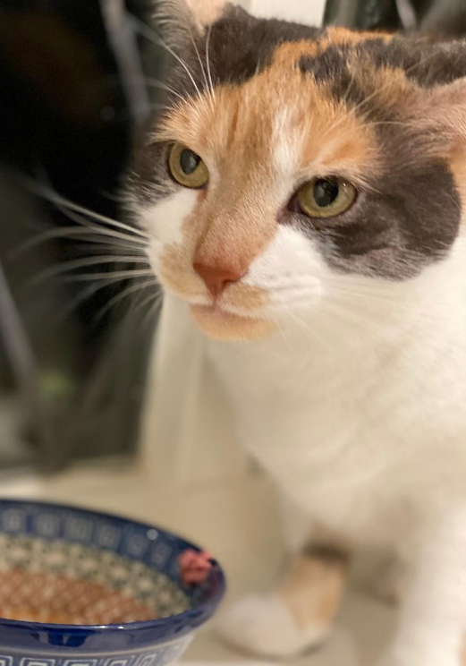 | 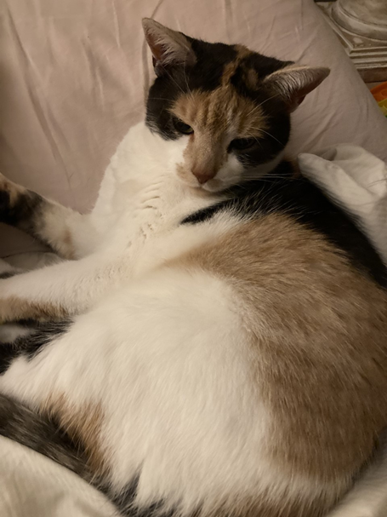
Last seen on Cooper Road on 21st September at 3pm. If you have any information or have seen her please call Georgia on
07901 536 051

